Grazioso Salvare Rescue Animal Dashboard
Project Overview
This project is a Python-based interactive dashboard created for Grazioso Salvare. The purpose of the dashboard is to make it easier to identify animals that meet specific rescue criteria and view their information in one place.
The dashboard connects to a MongoDB database through a Python CRUD module. Users can select different rescue types, and the dashboard updates the data table, breed chart, and map based on the selected criteria.
The main rescue options are:
- Water Rescue
- Mountain or Wilderness Rescue
- Disaster or Individual Tracking
- Reset
I built the dashboard with the goal of keeping the interface simple and easy to use while still providing the information needed to make decisions about potential rescue animals.

Features
MongoDB Database Access
The dashboard uses the AnimalShelter CRUD Python module to communicate directly with MongoDB. The module handles the database connection and read operations used by the dashboard.
The dashboard loads the database records into a Pandas DataFrame so the results can be displayed through Dash components.
Interactive Rescue Filters
The dashboard provides four radio-button options:
- Water Rescue — filters for animals that meet the Water Rescue requirements.
- Mountain or Wilderness Rescue — filters for animals that meet the Mountain/Wilderness requirements.
- Disaster or Individual Tracking — filters for animals that meet the Disaster/Individual Tracking requirements.
- Reset — returns the dashboard to the full dataset.
The filters use MongoDB queries through the CRUD module rather than only filtering the data after it has been loaded.
Interactive Data Table
The data table displays the database records returned by the selected filter.
The table includes:
- Sorting
- Filtering
- Pagination
- Single-row selection
- Animal information
- Breed information
- Rescue-related information
- Location coordinates
Selecting a row also allows the selected animal's location to be displayed on the map.
Breed Chart
The dashboard includes a horizontal bar chart showing the Top 10 Breeds by Animal Count in the unfiltered view.
When a rescue filter is selected, the chart updates to show the breeds represented by the filtered results. I chose a bar chart instead of the original pie chart because it makes it easier to compare breed counts, especially when the full dataset contains many different breeds.
Geolocation Map
The dashboard includes an interactive map that displays the location associated with the selected animal record.
The map updates when the table data changes, allowing the user to see where the currently selected animal is located.

Technologies and Tools
The following technologies were used to develop the project:
- Python — main programming language
- MongoDB — database used to store the animal shelter records
- PyMongo — database access through the CRUD module
- Dash / JupyterDash — interactive dashboard framework
- Plotly — interactive breed chart
- Dash Leaflet — interactive geolocation map
- Pandas — data manipulation and DataFrame creation
- NumPy — supporting data analysis functionality
- JupyterLab — development and execution environment
- Codio — course development environment
I used these tools because they work well together for a database-driven dashboard. MongoDB provides flexible access to the animal records, while the CRUD module keeps database operations separate from the dashboard interface. Dash makes it possible to connect the filters, table, chart, and map so that they respond to user input.

Dashboard Screenshots
Reset / Starting State
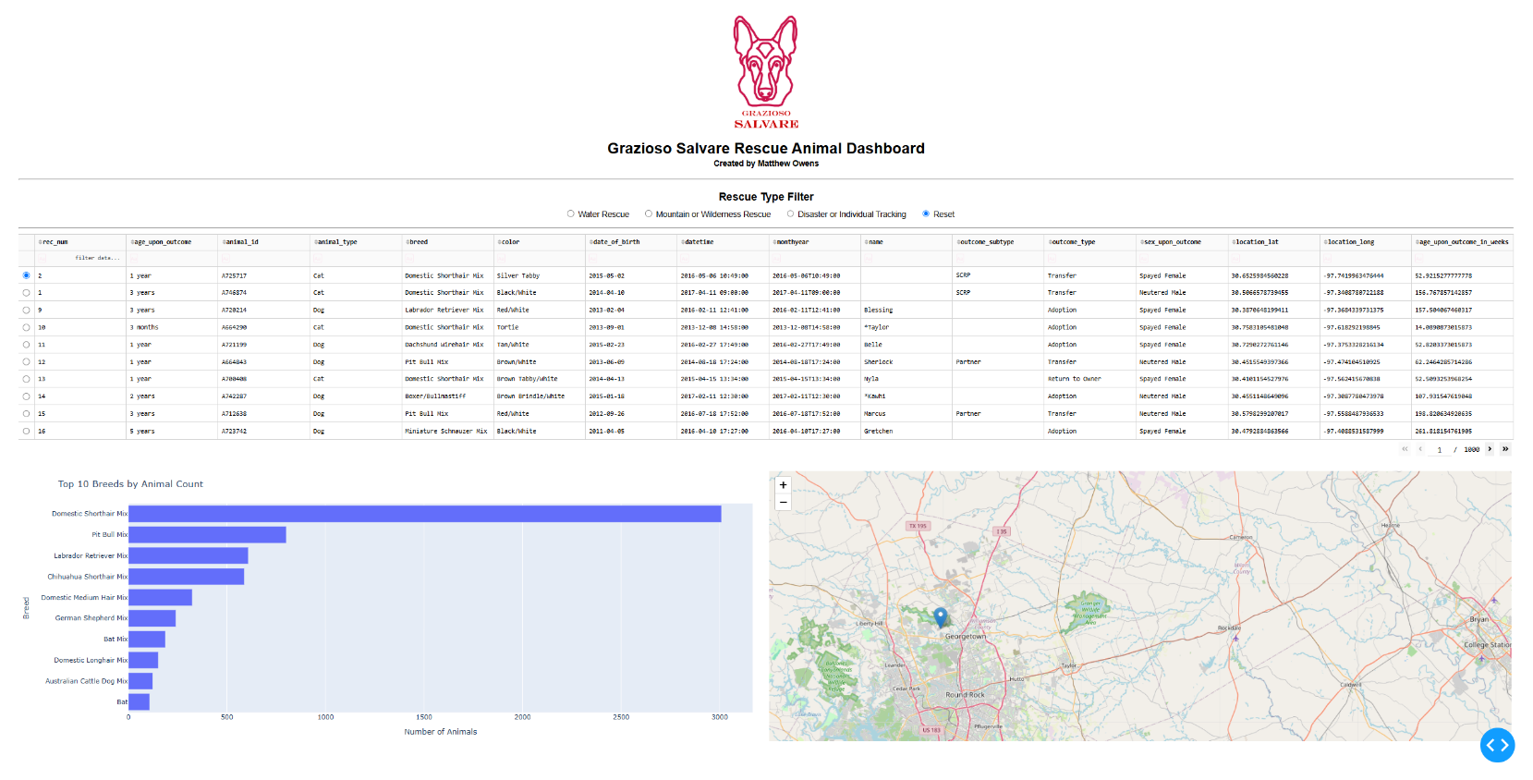
The Reset view displays the full dataset and provides the starting point for the dashboard.
Water Rescue
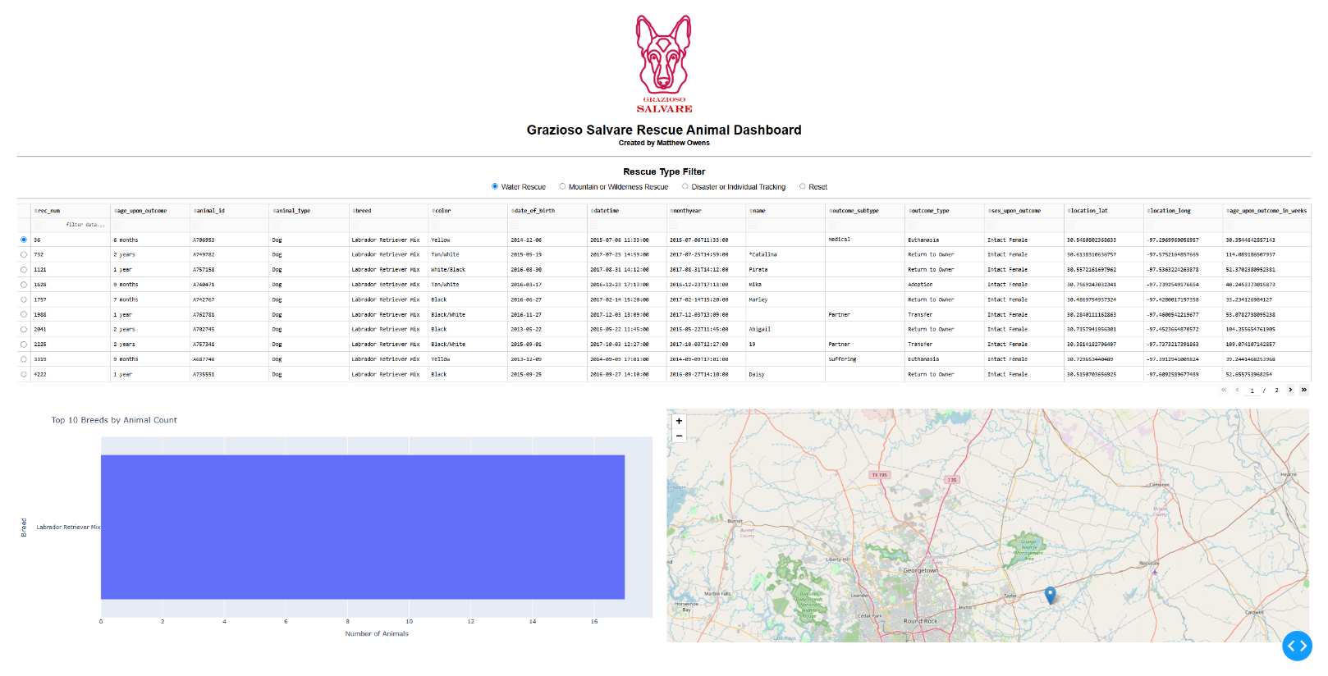
The Water Rescue filter displays animals that meet the requirements for water rescue operations.
Mountain or Wilderness Rescue
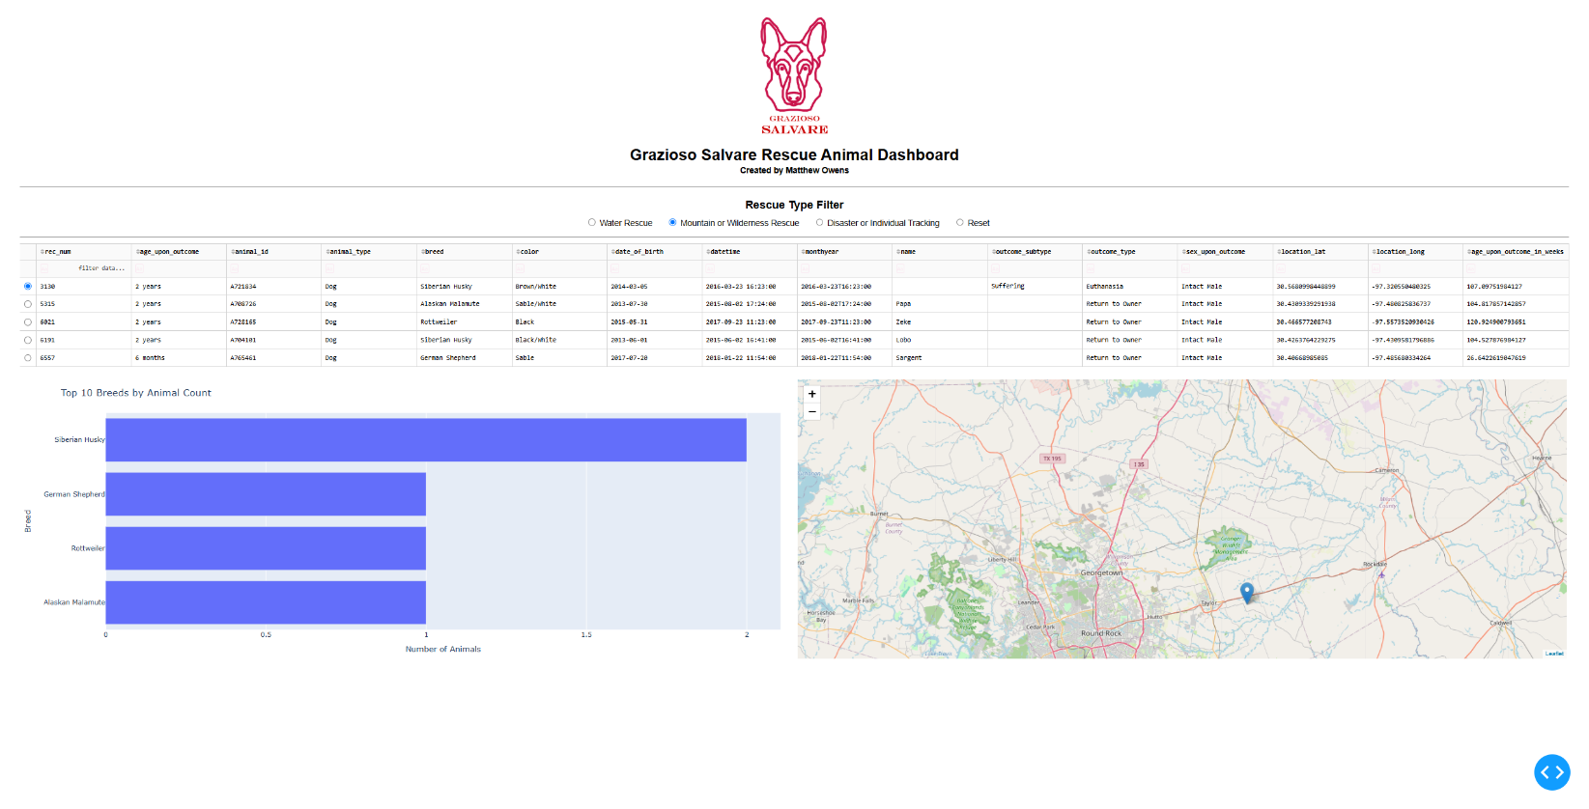
The Mountain or Wilderness Rescue filter displays animals that meet the requirements for mountain or wilderness rescue operations.
Disaster or Individual Tracking
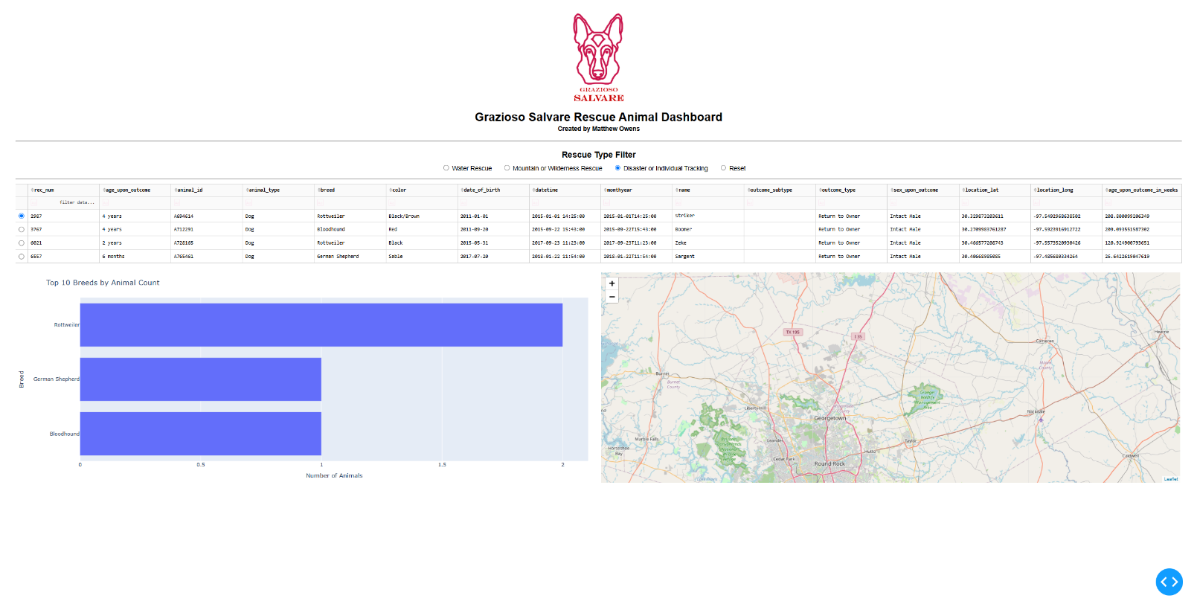
The Disaster or Individual Tracking filter displays animals that meet the requirements for disaster response or individual tracking.

How to Reproduce the Project
1. Set Up the MongoDB Database
The dashboard requires the animal shelter dataset to be loaded into MongoDB before the dashboard is started.
The MongoDB database should contain the animal shelter collection used by the CRUD module.
2. Configure the CRUD Python Module
The dashboard imports the CRUD class with:
from CRUD_Python_Module import AnimalShelter
The database credentials are configured in the dashboard code:
username = "aacuser"
password = "<your MongoDB password>"
db = AnimalShelter(username, password)
If the database credentials or CRUD module filename are different in another environment, those values need to be updated before running the dashboard.
3. Start the Jupyter Environment
Open the Project Two notebook in JupyterLab/Codio and make sure the required Python packages are available.
The dashboard uses JupyterDash, Dash, Plotly, Pandas, Dash Leaflet, and PyMongo.
4. Run the Dashboard
Run the notebook cells in order.
The dashboard loads the database records through the AnimalShelter CRUD module and then starts the JupyterDash application.
The final cell starts the application with:
app.run_server()
Once the server starts, open the provided Jupyter/Codio dashboard URL.
5. Test the Filters
Start with Reset to confirm the full dataset is displayed.
Then test each rescue option:
- Select Water Rescue.
- Select Mountain or Wilderness Rescue.
- Select Disaster or Individual Tracking.
- Select Reset again.
For each filter, verify that the data table, breed chart, and map update.

Challenges and Solutions
One of the first problems I ran into was getting the dashboard to recognize my CRUD Python module. The dashboard initially returned a ModuleNotFoundError because the import did not match the name of the Python file in the project.
I corrected the import so the dashboard could access the AnimalShelter class. After that was fixed, the database connection and dashboard loaded successfully.
Another challenge was making the chart useful with the full animal shelter dataset. The original pie chart became difficult to read because there were many different breeds. I changed the chart to a horizontal bar chart and limited the unfiltered view to the top 10 breeds by animal count. This made the results much easier to compare while still allowing the chart to update when a rescue filter was selected.
I also adjusted the dashboard layout to reduce unnecessary whitespace and keep the table, chart, and map organized on the page.

